**Instruction:** Examine the two descriptions of this boats and make the corresponding comparisons using the following adjectives: short, long, big, small, fast, slow, old, new, cheap, expensive.

*Examples:*

*The Black Pearl is longer than the fisher´s boat.*

*The fisher´s boat is shorter than the Black Pearl.*

**A fisher´s boat**

Length: 9 meters

Area: 23 meters

Top Speed: 30 knots

Year Made: 1997

Price: £3,500

**The Black Pearl**

Length: 14 meters

Area: 40 meters

Top Speed: 35 knots

Year Made: 2011

Price: £9,000

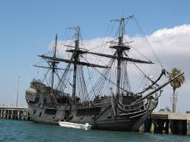

**Evaluation:**

|  |  |  |  |  |
| --- | --- | --- | --- | --- |
| CATEGORY | EXCELLENT | GOOD | REGULAR | LIMITED |
| EXERCISE | The exercise is correct and complete. | More than half of the exercise is correct. | Less than half of the exercise is correct. | The exercise is incomplete and incorrect. |

*Send it through Virtual Platform.*

*Remember: the name of the file should be:*

***Last Name_Given Name_Comparison_ Boats***