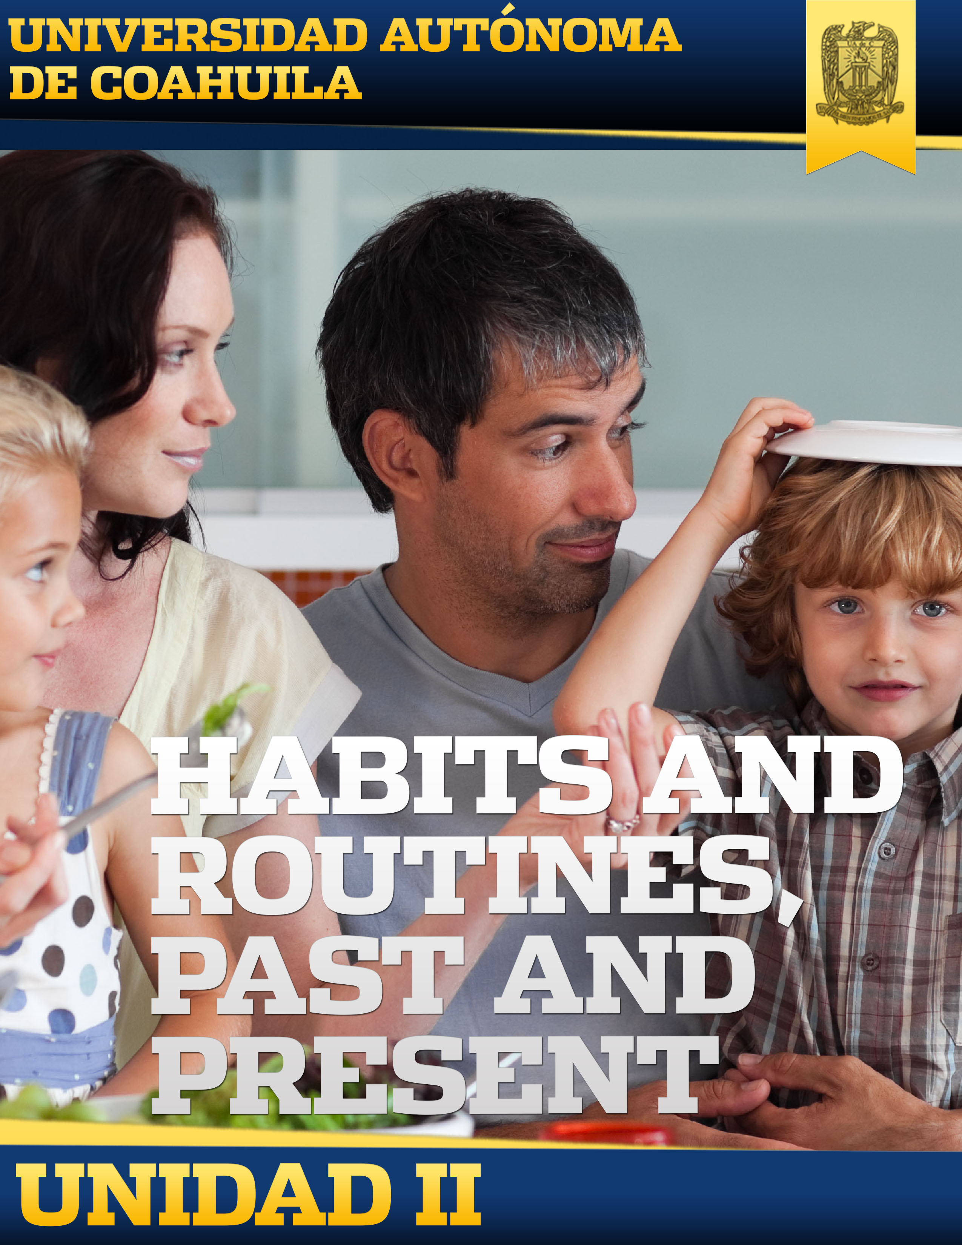

Introduction

Welcome to block II. Here you'll learn:

• Grammar: Used to in its different forms, regular and irregular verbs in the past simple.

• Vocabulary: hobbies, family, family history and school days.

Remember if you have any question, you should be establishing contact with your teacher by chat or e-mail.

General Competence Of The Block

The student will be able to apply the “Used to” to compare habits and routines from the past and the present in social and family contexts in a natural and respectful manner.

Knowledge Requirements

|  |  |  |
| --- | --- | --- |
| KNOWLEDGE | HABILITIES | ATTITUDES AND VALUES |
|  |  |  |
| * Used to. * Home, family, school, hobbies. * Used to interrogative form. * Fashion and style. * Used to negative. * Past habits and customs. * Used to with adverbs of frequency. * Life in the past, family history. * Used to review all forms. * Size, measurements, food portions. * Simple past: regular and irregular verbs. * School days, incidents. | * Identifies and understands main ideas in intermediate texts. * Understands main ideas in an oral or written text about past routines and habits. * Writes and reads texts related to the topic with greater complexity than in the previous levels. * Uses vocabulary in a communicative situation related to habits, work, study, leisure, and transportation. * Practice correct pronunciation. | * Participates in conversations with a positive and empathetic attitude. * Is open to feedback. * Shows initiative and interest in learning and finding information that goes beyond. |

Map of Content

Evaluation

|  |  |
| --- | --- |
| Evaluation | Percentage |
| Used To | 3% |
| Used to negative | 1% |
| Used to with adverbs of frequency | 1% |
| Narrative Life in the past | 2% |
| Used To Review | 1% |
| Food Portions | 1% |
| Regular and Irregular Verbs | 3% |
| Complete a Paragraph | 2% |
| Practice Regular and Irregular Verbs | 3% |
| Read | 3% |
| Total: | 20% |

Activities Of The Block

|  |  |  |
| --- | --- | --- |
| Topic | Subtopic | Activity |
| No Longer | Used To | Used To |
| Home, family, school, hobbies |
| Fashion Frenzy | Used to interrogative form |
| Fashion and style |
| Used to negative | Used to negative |
| By Word Of Mouth | Used to with adverbs of frequency | Used to with adverbs of frequency |
| Life in the past, family history | Narrative Life in the past |
| The Changing Shape Of Things | Used to review all forms | Used To Review |
| Size, measurements, food portions | Food Portions |
| The Best Days Of Your Life  The Best Days | Simple past: regular and irregular verbs | Regular and Irregular Verbs |
| Complete a Paragraph |
| School days, incidents | Practice Regular and Irregular Verbs |
| Read |