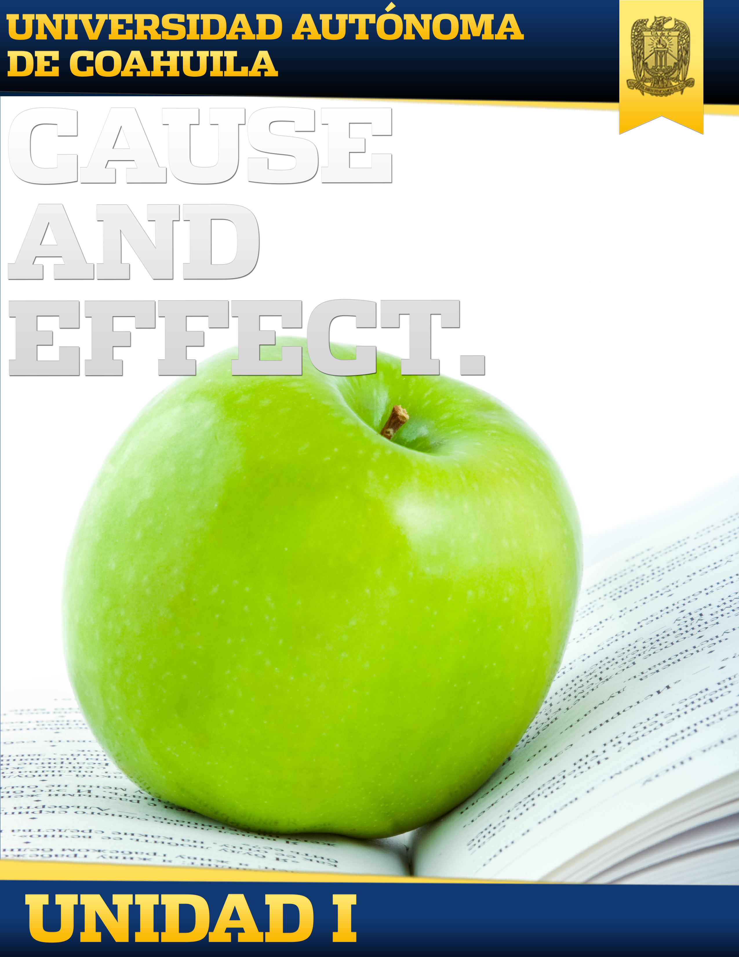

Introduction

Welcome to block I. In this block you will learn:

• Grammatically: the conditional zero and the first conditional.

• Vocabulary: body parts, how to express the changes in climate and environment.

This block helps you learn new gramatical forms. I wish you success!

Remember that for any questions you can always go by different means your facilitator.

General Competence Of The Block

Uses the present and the future tenses to describe oral and written facts and situations in personal, social, and work settings with cause and effect in a respectfully manner.

Knowledge Requirements

|  |  |  |
| --- | --- | --- |
| KNOWLEDGE | ABILITIES | ATTITUDES AND VALUES |
|  |  |  |
| * Zero Conditional. * If + simple present. * Universal truths. * First conditional with will. * Water management. * First conditional with unless. * Climate and environment. * First conditional with modals. * Stress symptoms and treatments. * Vacation activities. * Part time jobs. | * Identifies and understands main ideas in an oral or written description about cause and effect. * Identifies key information in a listening text related to the unit topic. * Uses correct vocabulary and grammar when presented with communicative situations. * Asks for and gives information about cause and effect. * Practice correct pronunciation. | * Participates in conversations with a positive and empathetic attitude. * Is open to feedback given. * Shows initiative and interest in learning and finding information that goes beyond. |

Mapa De Contenido

Evaluation

|  |  |
| --- | --- |
| **Evaluation** | **Percentage** |
| Zero conditional exercise | 2% |
| Practice Zero conditional | 1% |
| Sentences with Zero Conditional | 2% |
| Parts of the body | 1% |
| Relationship | 1% |
| Complete | 2% |
| Match | 2% |
| Plumbing Words Presentation | 2% |
| Description Climate change and Environment | 2% |
| Practice first conditionals with Modals | 2% |
| Reading | 2% |
| Zero Conditional or First Conditional | 1% |
| **Total:** | **20%** |

Activities Of The Block

|  |  |  |
| --- | --- | --- |
| Topic | Subtopic | Activity |
| The Bare Facts | Zero Conditional | Zero conditional exercise |
|  | Practice Zero conditional |
| If+ simple present | Sentences with Zero Conditional |
| Universal Truths | Parts of the body |
| The Magic of Science | Experimental language | Relationship |
| Scientific words |
| The Weather Crisis | First conditional with will | Complete |
|  | Match |
| Plumbing words | Plumbing Words Presentation |
| Water management |
| The Life and Death Issue | First conditional with unless | Description Climate change and Environment |
| Climate change |
| Environment | Practice first conditionals with Modals |
| Uneducated Guesses | First conditional with modals | Reading |
| Stress symptoms and treatments |
| Planning for Spring Break | Zero conditional vs. First conditional | Zero Conditional or First Conditional |