**Instruction:**

Complete the following crossword, use the correct phrasal verbs.

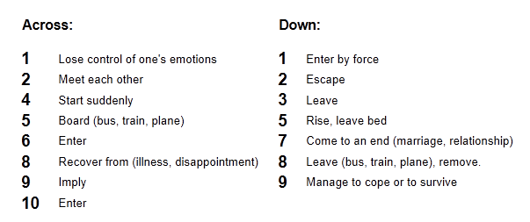

Remember to up load your work in to the virtual platform.

The name of the file should be:

**Last Name_Given Name_Phrasal Verbs**

**Last Name_Given Name_Crossword_Vocabulary**

|  |  |  |  |  |  |  |  |  |  |  |  |  |  |  |  |  |  |  |
| --- | --- | --- | --- | --- | --- | --- | --- | --- | --- | --- | --- | --- | --- | --- | --- | --- | --- | --- |
|  |  |  |  |  |  |  |  |  |  | **1B** |  |  |  |  |  |  |  | **N** |
| **2 G** |  |  |  |  | **3 G** |  |  |  |  |  |  |  |  |  |  |  |  |  |
|  |  |  |  |  |  |  |  |  |  |  |  |  |  |  |  |  |  |  |
|  |  |  |  |  |  |  | **4B** |  |  |  |  | **O** |  |  |  |  |  |  |
|  |  | **5 G** |  |  |  | **N** |  |  |  |  |  |  |  |  |  |  |  |  |
|  |  |  |  |  |  |  | **6G** |  |  |  |  |  | **O** |  |  |  |  |  |
|  |  |  |  |  |  |  |  |  |  |  |  |  |  | **7B** |  |  |  |  |
| **Y** |  |  |  |  |  |  |  | **8G** |  |  |  |  |  |  |  |  |  |  |
|  |  |  |  |  |  |  |  |  |  | **O** |  |  |  |  |  |  |  |  |
|  |  |  |  | **9G** |  |  |  |  |  |  |  |  |  |  |  |  |  |  |
|  |  |  |  |  |  |  |  |  |  |  |  |  |  |  |  |  |  |  |
|  |  | **10G** |  |  |  | **N** |  |  |  |  |  |  |  |  |  |  |  |  |
|  |  |  |  |  |  |  |  |  |  |  |  |  |  | **P** |  |  |  |  |
|  |  |  |  | **Y** |  |  |  |  |  |  |  |  |  |  |  |  |  |  |