**What time do you do these activities?**

Write a sentence with each verb according to your routine. Add in all the sentences the person (I), a frequency adverb before the verb, and the preposition *at* before the time.

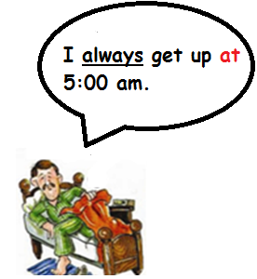**Example:**

1. Get Up





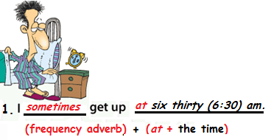

|  |  |
| --- | --- |
| Write Sentence with… | Sentence |
| 1. Take a shower |  |
| 1. Get dressed |  |
| 1. Have breakfast |  |
| 1. Go to work/school |  |
| 1. Star work/school |  |
| 1. Have lunch |  |
| 1. Finish work |  |
| 1. Arrive home |  |
| 1. Have dinner |  |
| 1. Watch TV |  |
| 1. Go to bed |  |

Send it through Virtual Platform.

Remember, the name of the file should be:

***Last Name_Given Name_E_Time_Expressions***