**Exercise taken from Open Mind 1, 2010, p. 82.**

**Read this review. Circle the correct option to answer the question.**

**Are you looking for the** perfect gift to Father’s Day?

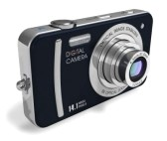Then how about the new Ikon ZX8S digital camera? It looks cool and it takes fantastic pictures. It’s **cheaper** *than* other cameras, too. The ZXTi, for example, is **more expensive**, but I don’t think it takes very good pictures. It’s also **bigger** *than* the ZX8S. The ZX8S is **smaller**, so it’s **better** for vacations or traveling. It’s **more versatile** *than* other cameras, and it’s **prettier**. I’m giving the ZX8S 4.5 stars!

-Review by Ian Atkinson, Atlanta

**Which camera does the reviewer prefer?**

A) the ZXTi camera B) the ZX8S camera

**Read the review in Exercise A again. Look at the highlighted phrases. Complete these spelling rules for comparative adjectives.**

|  |  |
| --- | --- |
| **One syllable adjectives** | For most, add *–er*: old-older, smart-smarter, cheap- (1)  For adjectives which end in consonant-vowel-consonant, double the final consonant and add *–er*: thin-thinner, hot-hotter, big -(2)  *e.g. This camera is smaller/bigger than that one.* |
| **Two syllable adjectives ending in**  ***-y*** | Change the *y* to *i* and add *–er*: happy-happ*ier*, funny-funn*ier*, pretty- (3)  *e.g. This photo is funnier than her photo.* |
| **Adjectives with two or more syllables** | User more: interesting-more interesting, compact-more compact, expensive-(4)  *e.g. The ZXTi is more expensive than the ZX8S.* |
| **Irregular adjectives** | Bad-worse, good (5)  *e.g. Tom’s camera is worse than this one*. |

**Exercise taken from Open Mind 1, 2010, p. 83.**

**Complete these sentences with the correct comparative form of the adjective in parentheses + *than*.**

1. This laptop is       (versatile) mine.
2. Your furniture is       (nice) your neighbor’s furniture.
3. Shopping online is       (easy) going to the store.
4. My cellphone is       (up-to-date) yours.
5. These jeans are       (good) those.
6. Mike’s old MP3 player is       (big) his new one.

**Look at the pairs of pictures and write a comparative sentence as explained previously for each one.**

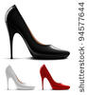**.**

***e.g. The black shoes are nicer than the red ones. They are cheaper, too***.

1. 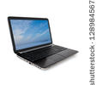
2. 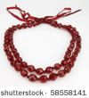
3. 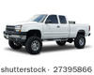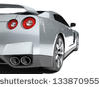

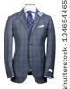

1. 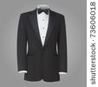

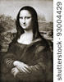





Write a paragraph describing at least 5 things you saw the last time you went shopping (food, clothes, gadgets, CDs, etc.).

Send it through Virtual Platform.

Remember, the name of the file should be:

**Last Name_Given Name_A_Practicing**