Exercise taken from Open Mind 1, 2010, p. 126.

**Complete the conversation between Max and Jim with *going to* and the verb in parentheses.**

**Jim: Hey, I hear you’re going to the beach next week. What (1)** **you       (do) while you’re there?**

**Max: Well, I (2)       (relax). I (3)       (not think) about work for a week. I (4)       (read) a good book, play tennis, and lie on the beach.**

**Julie (5)       (take) surfing lessons. She doesn’t like too much relaxation.**

**Look at the pictures. Write about what each person is going to do.**

1. 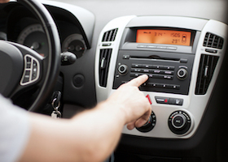

***e.g.* Maria is going to play music in her car.**

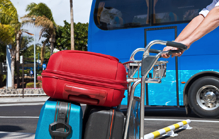



1. 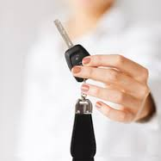





**6.**

**Watch the following video. What are the differences between Present Progressive for future, and Going to? Write some examples discussed in the video.**

**http://www.youtube.com/watch?v=d4C_dH8LgUA**

**____________________________________________________________________________________________________________________________________________________________________________________________________________________________________________________________________________________________________________________________**

**The activity has more than half of the total correct answers. 2%**

**The activity has half of the total of correct answers. 1%**

**The activity has more than half of mistakes 0.5%**

Send it through Virtual Platform.

Remember, the name of the file should be:

**Last Name_Given Name_A_Going_To**