**Take one minute for the following culture quiz!**

Choose the correct answer to complete each sentence.

|  |
| --- |
| Frida Kahlo |
| Wolfgang Amadeus Mozart |
| Salvador Dalí |
| Romeo and Juliet |
| Charles Chaplin |

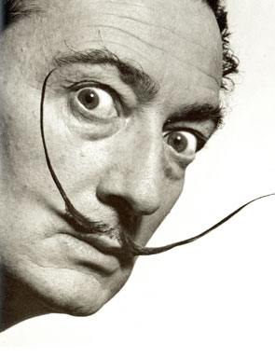

1. The artist’s name was

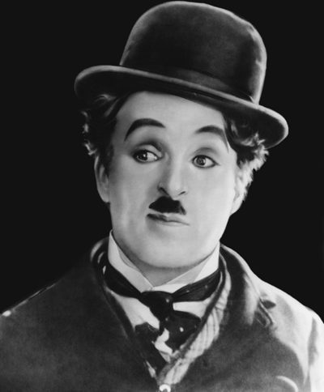

2.This British actor’s name was

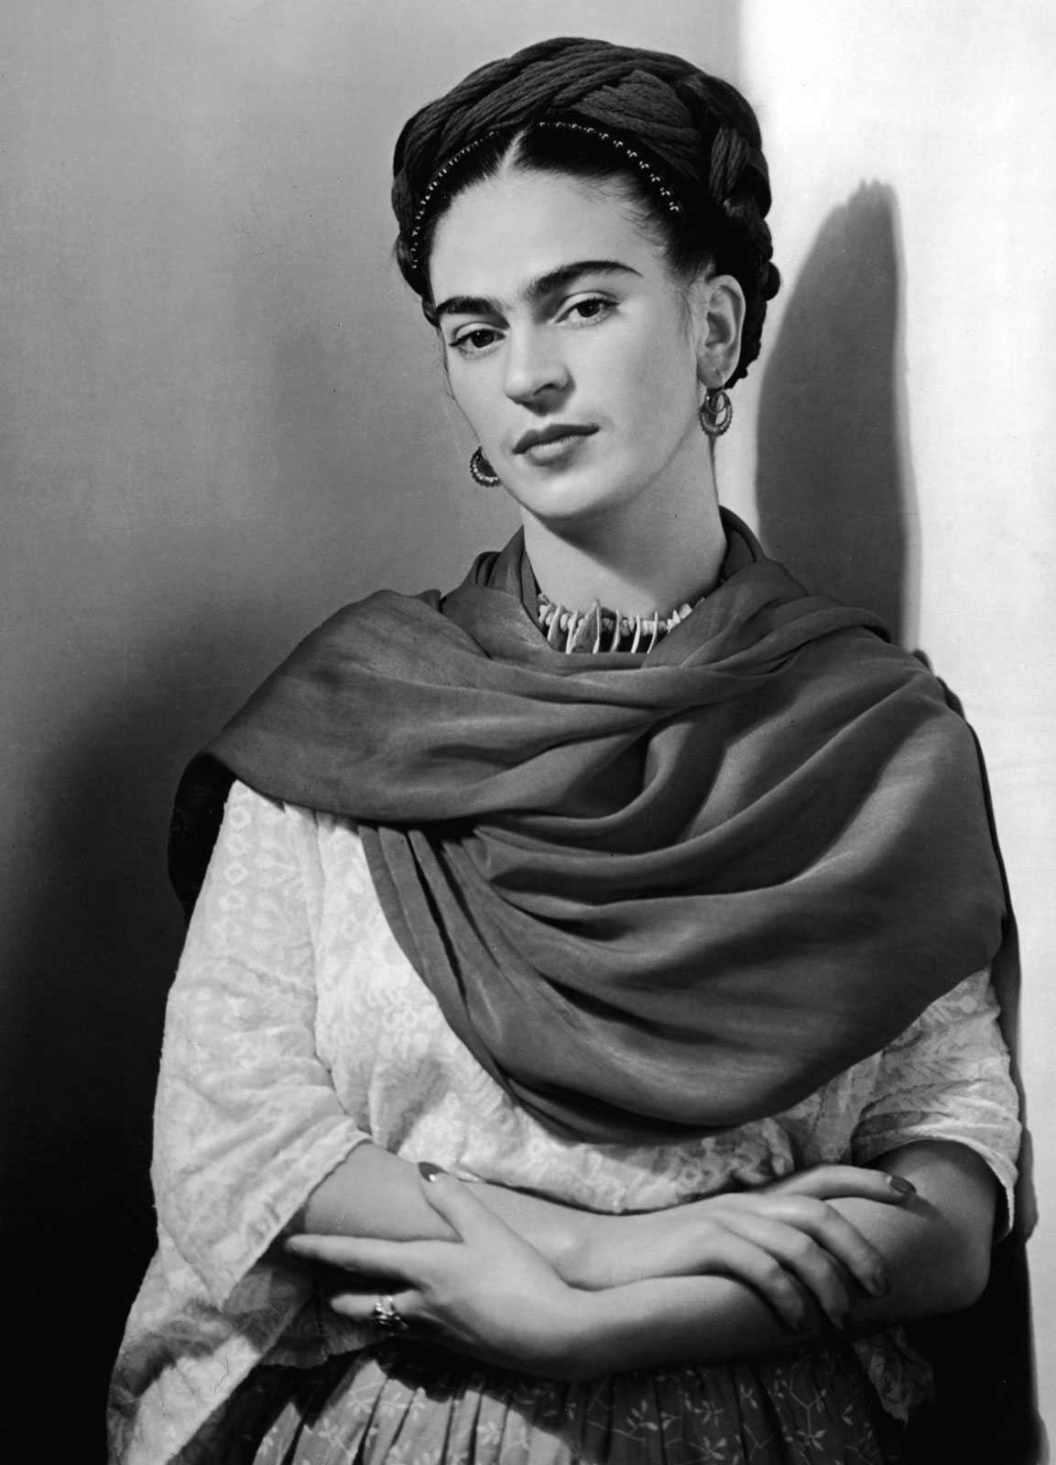

3. This Mexican female artist was

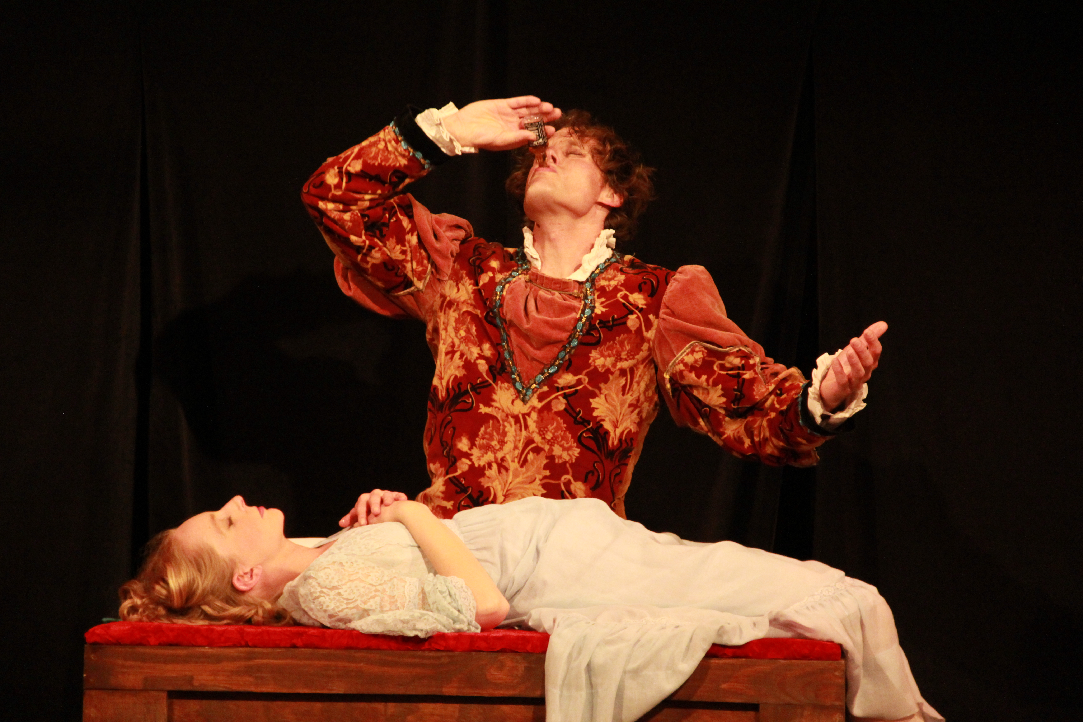

4.The name of the theater play was

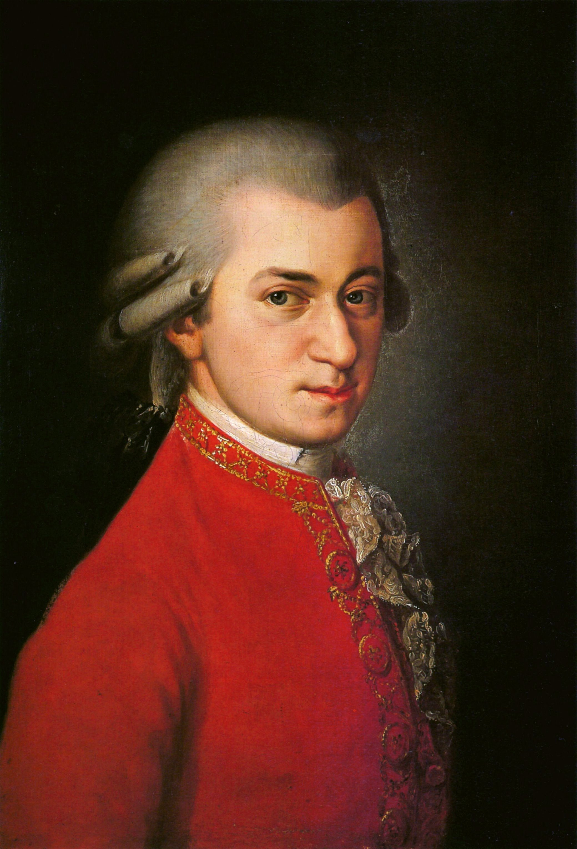

5. This brilliant composer’s name was

***Remember to upload your work in to the virtual platform.***

***The name of the file should be: Last Name_Given Name_E_Drill_Practice***