**VOCABULARY: OBJECTS IN A HOUSE**

**1. Look at the pictures below and label the names of the items.**

~~desk~~ refrigerator armchair sofa lamp washing machine plant bed faucet mirror TV shower stove sink (X2) cabinet chairs coffee table table curtains bathtub

**Macintosh HD:Users:virtual:Desktop:Imagenes:shutterstock_156183467.eps**

***desk***

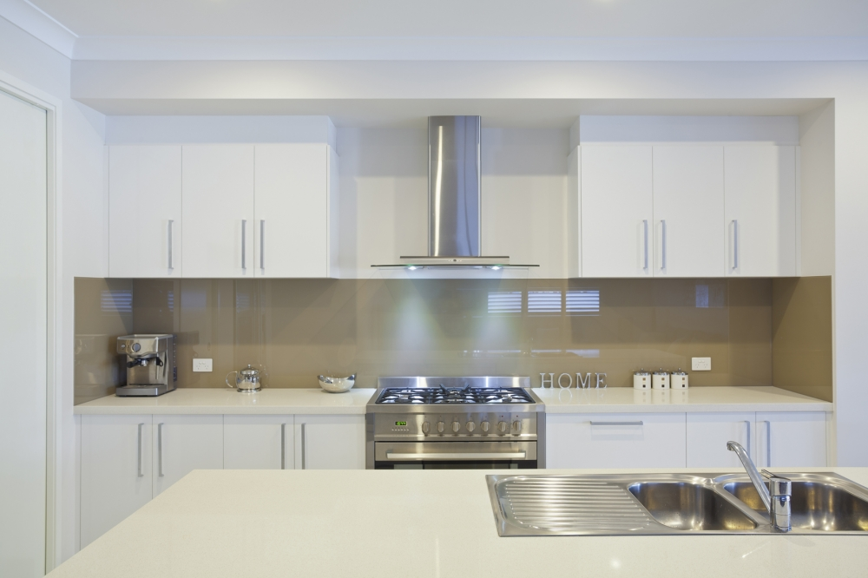Macintosh HD:Users:virtual:Desktop:Imagenes:shutterstock_167019074.eps

**2 . Write the vocabulary above in the corresponding room column. Some nouns can be placed in more than one column.**

|  |  |  |  |  |
| --- | --- | --- | --- | --- |
| Living room  Macintosh HD:Users:virtual:Desktop:UNIT 2:Fotos:SLIDE-1.jpg | Kitchen Macintosh HD:Users:virtual:Desktop:UNIT 2:Fotos:82.jpg | Bedroom  Macintosh HD:Users:virtual:Desktop:UNIT 2:Fotos:fototres1.jpg | Bathroom  Macintosh HD:Users:virtual:Desktop:UNIT 2:Fotos:bathroom-with-window.jpg | Laundry room  Macintosh HD:Users:virtual:Desktop:UNIT 2:Fotos:08 White Laundry with Beadboard Doors Brown Countertop.jpg |
|  |  |  |  |  |

**Remember to up load your work in to the virtual platform.**

**The name of the file should be: Last Name\_Given Name\_A\_Objects\_House**