VOCABULARY
Look at the pictures and complete these phrases with verbs from the box. Write your answer in red.

Find Miss Win Lose See Have Win Fail

 | 1. a celebritY
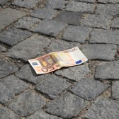 | 2. some money
 | 3. the lottery
 | 4. a plane
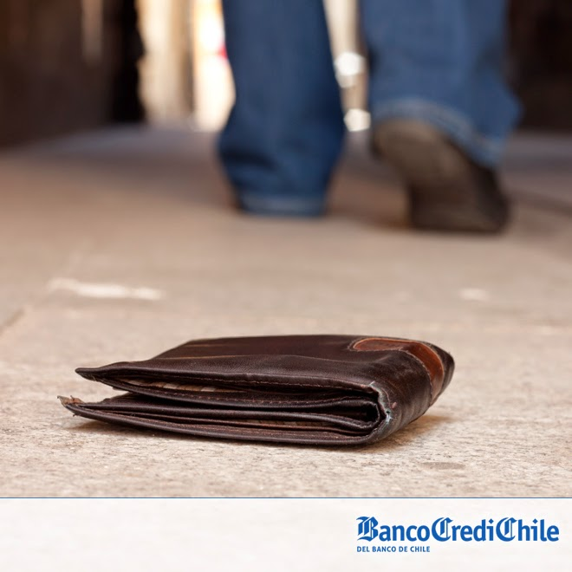 | 5. your wallet
 | 6. first place
 | 7. an accident
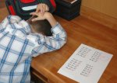 | 8. a test

Remember to up load your work in to the virtual platform.
The name of the file should be: Last Name_Given Name_E_Vocabulary

