**A QUESTION OF TASTE**

Pay attention to the following video, next answer the exercise.

Food and Drinks (with sound) - English Language. AMES836. Subido el 13/02/2012

<http://www.youtube.com/watch?v=bHJXsHf4Q6E>

**Listen to the food vocabulary and classify the nouns into the following categories:**

|  |  |
| --- | --- |
| DRINKS |  |
| VEGETABLES |  |
| FRUIT |  |
| MEAT |  |
| DAIRY PRODUCTS (DERIVATE OF MILK) |  |
| OTHERS |  |

**Match the countries to the foods. Do you know the name of each dish?**

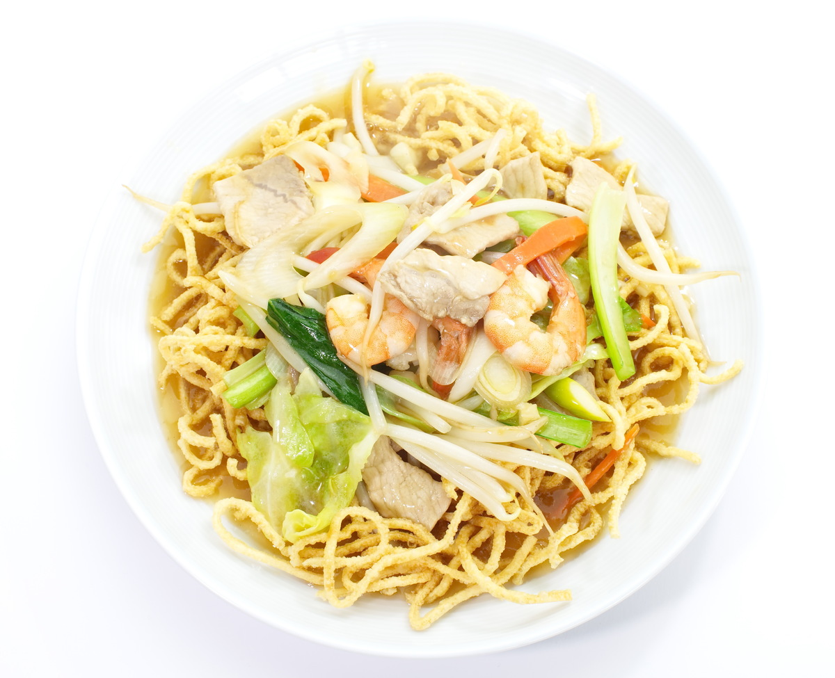**Share your opinion about your favorite types of food.**

1. 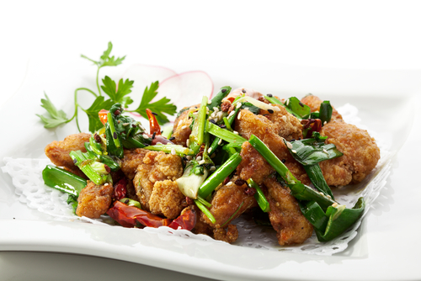France
2. 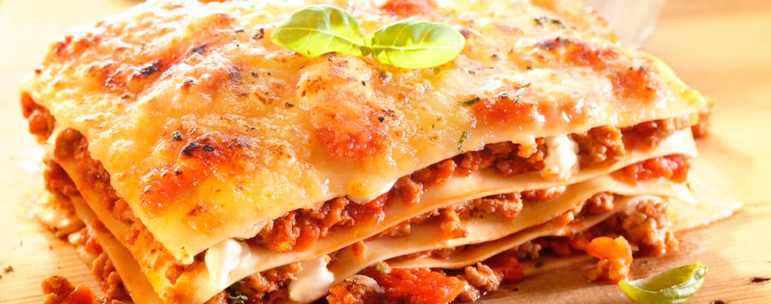Mexico
3. China
4. Italy

**Look at the pictures and choose adjectives to describe the taste/texture of the food.**

**sweet creamy spicy crunchy**

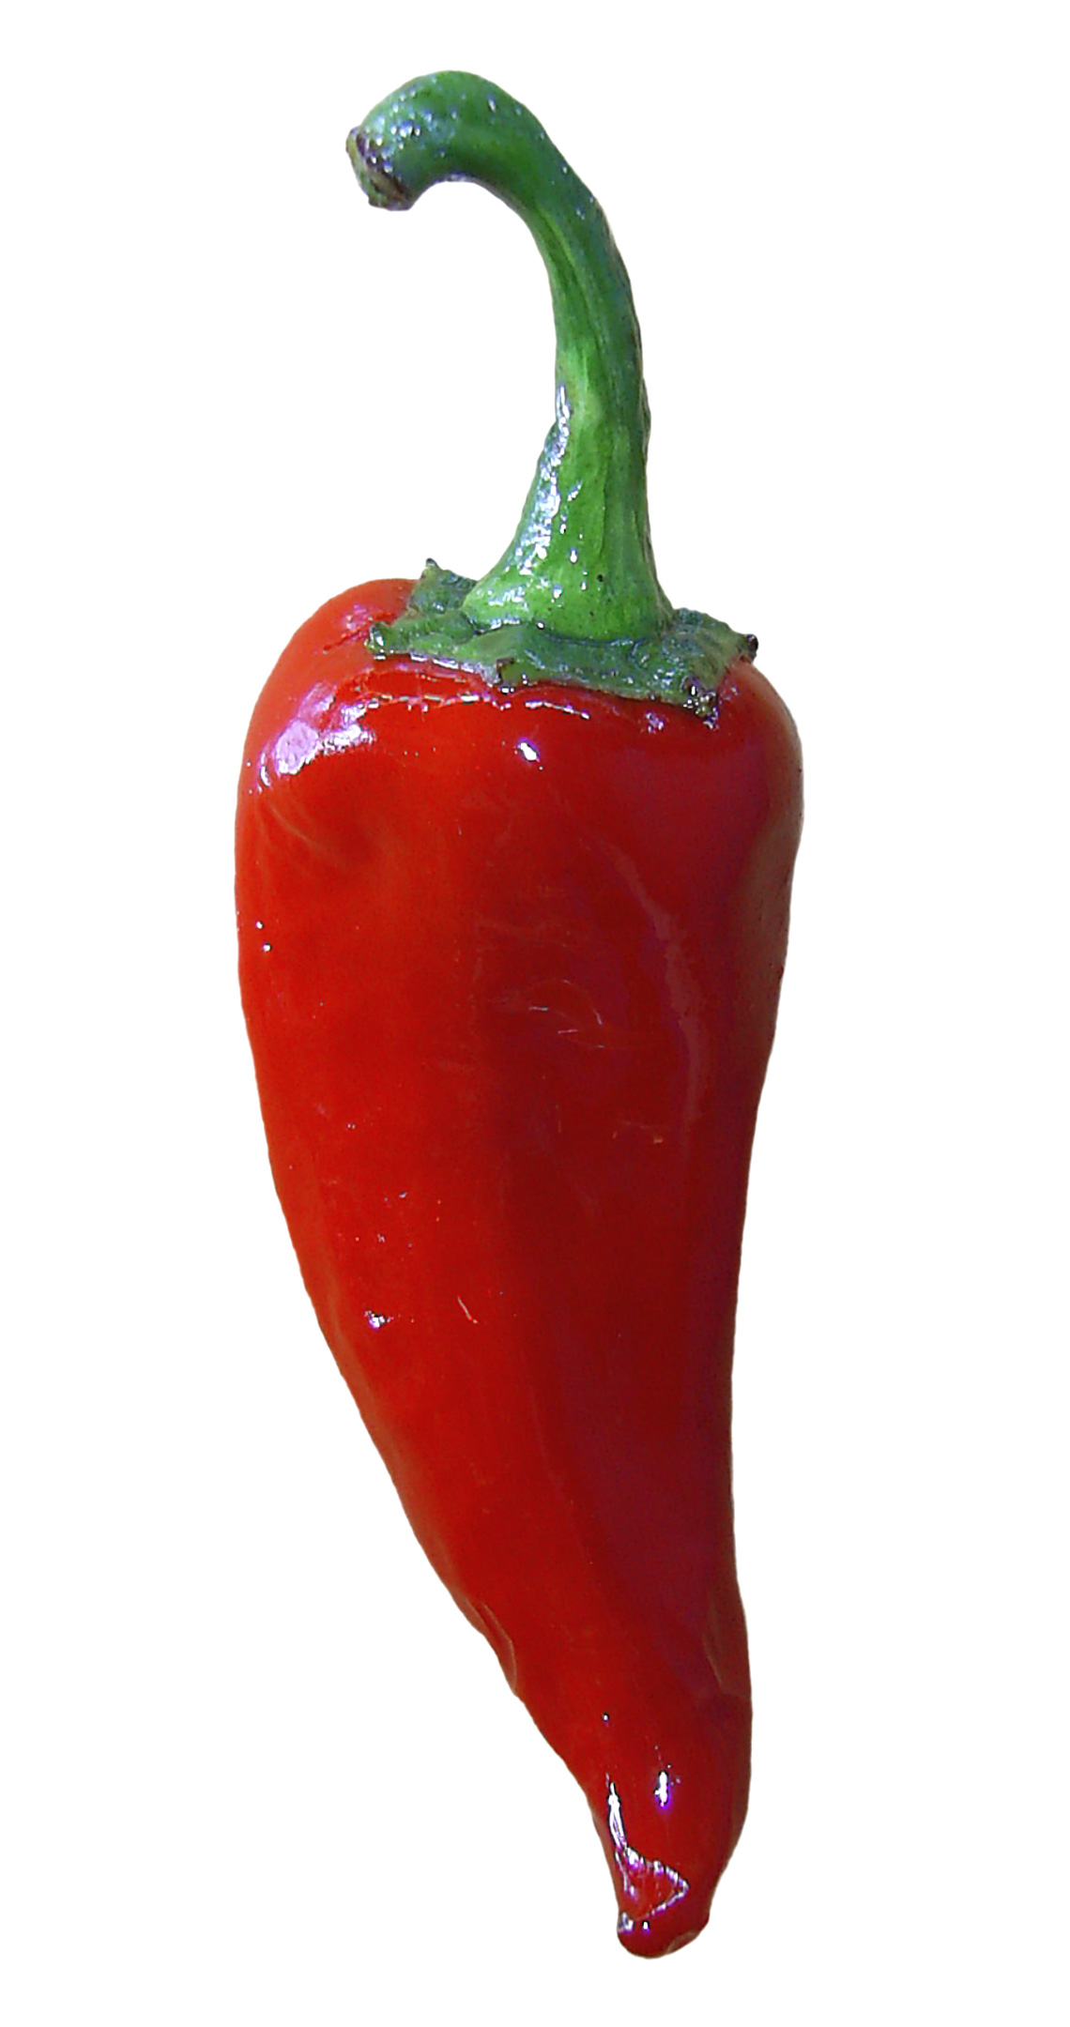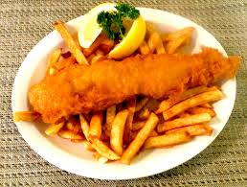

**greasy**

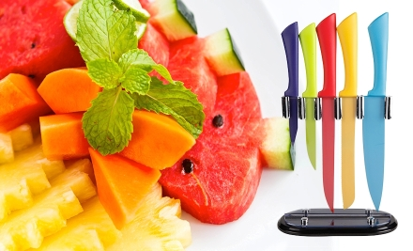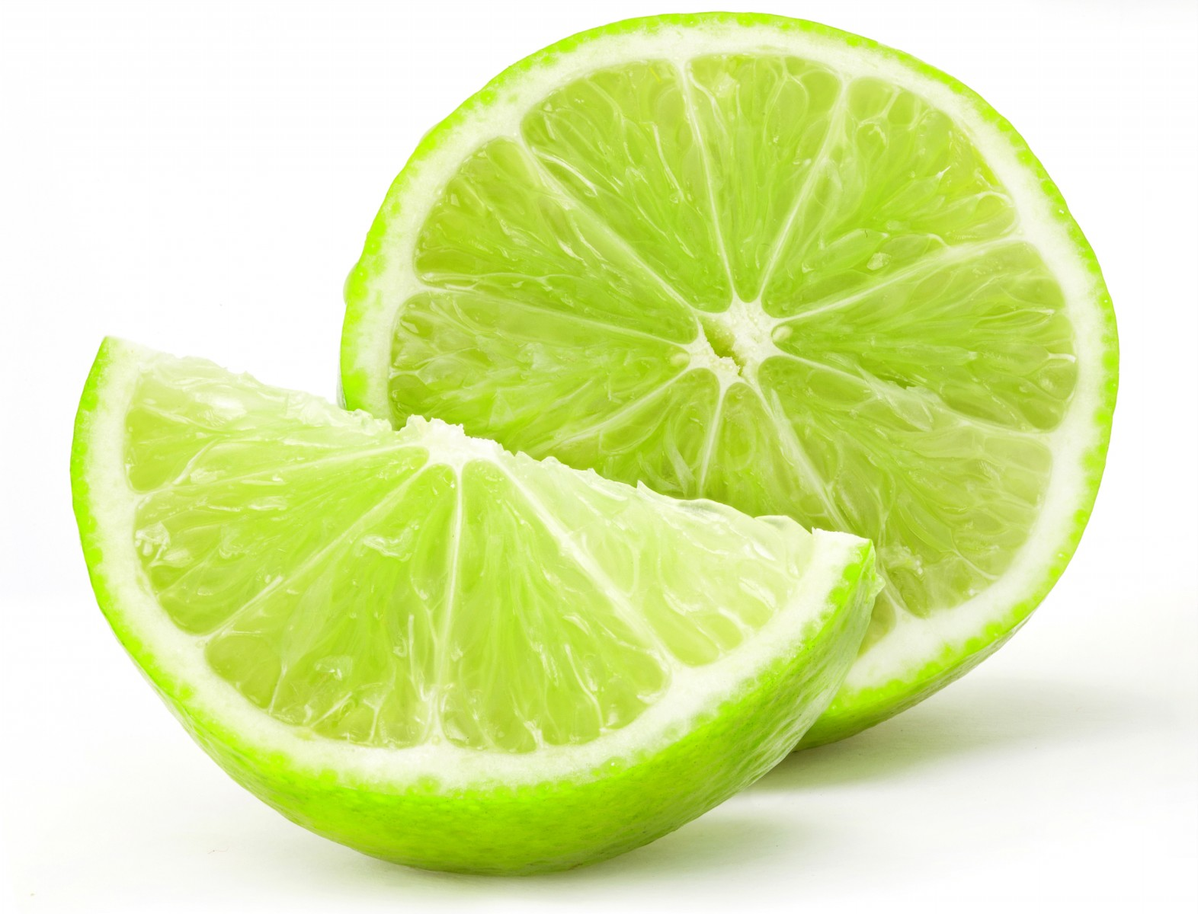

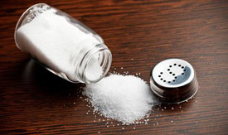

**sour**

**juicy**

**salty**

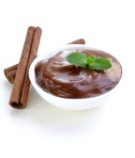

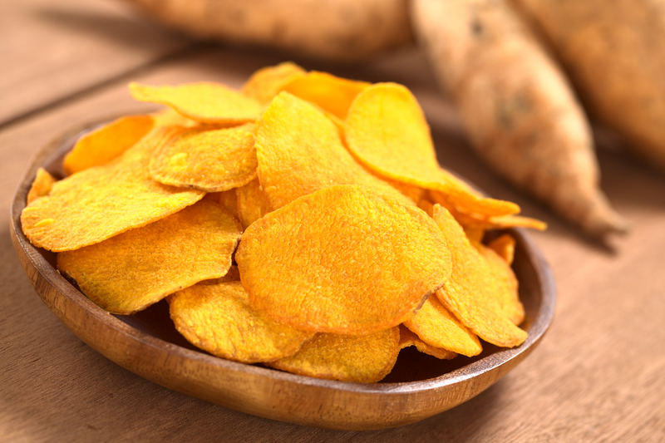

**Write one or two adjectives from above to describe the following food.**

lime       crackers       cake

Tabasco sauce       marmalade       steak

ice-cream       pizza       cereal flakes

banana       cookie       avocado

watermelon       fries       yoghurt

*Remember: the name of the file should be named:*

*Last Name/Given Name/E_Question_of_Taste*