1. Write in an e-mail to a friend who is in Germany. Tell your friend everything about the fund rising party for the foreign students that you attended yesterday.
2. You can also tell your friend about your plans to attend a wedding out of town on the weekend.
3. The letter must be at least 10 lines.

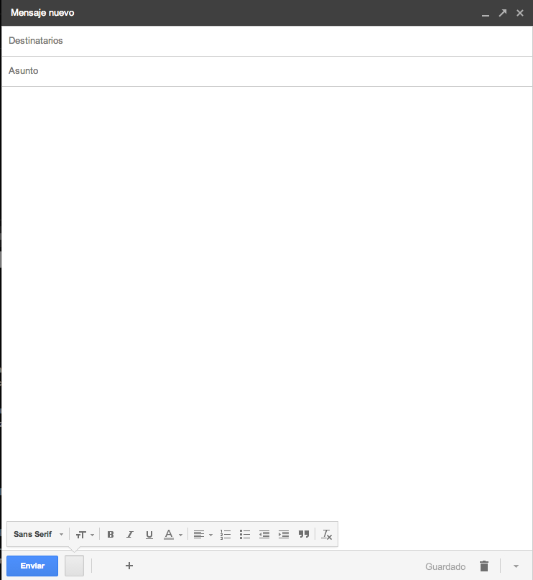

|  |
| --- |
|  |

Send it through Virtual Platform.

Remember, the name of the file should be:

**Last Name_Given Name_E_Email**